Drinking Water Supply and Quality

Fairfield is in a region of relative water abundance, but we’ve always had droughts as well as flooding. Climate scientists project that future episodes of drought and flooding are likely to intensify. In addition, our water supply is at risk from increasing population and commercial development.
Each day, Fairfield uses about 9 million gallons of drinking water from several watershed areas for commercial and residential use. The Aquarion Water Company maintains about 300 miles of water mains in Fairfield; the oldest mains are about 80 years old.

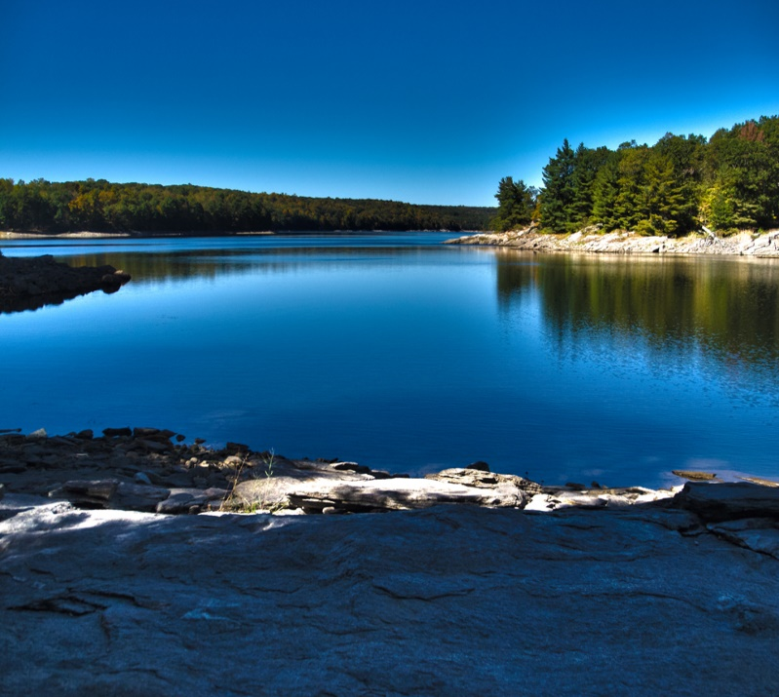
Aspetuck Reservoir – only minutes away from town

Achievements to Date
- Reliable supply of clean water for homes and businesses
- Water is monitored for general quality and regulated/emerging contaminants
- Watershed protection through partnership with the state’s Department of Energy and Environmental Protection (DEEP), Aquarion, and the Nature Conservancy
Challenges Ahead
- Ensuring that water supply and quality keeps pace with residential, municipal, and commercial development
- Ensuring reliable water delivery infrastructure
- Ensuring proactive response to drought conditions

Benefits of mindfully managing our water supply and use
- Stable water supply costs
- Using less energy to make hot water
- Lowering operating costs of wastewater treatment facility, thereby lowering taxes
- Creating a cushion against drought conditions
- Protecting our health and safety by protecting the quality of our water
- Stewardship of a precious and finite natural resource

2030 Plan Goals*
- Reduce Town per capita water use by 10%
- Develop a Town drought ordinance
- Maintain an effective fire prevention program
- Ensure an ongoing water main replacement program
- Support the current watershed management partnership
- Ensure that the regulated and emerging contaminants are adequately monitored
*Some goals are ambitious and may need more time to achieve target participation rates; others can be achieved sooner. Work on all goals should begin as soon as possible.

How Do We Reach Our Goals?
- Residential and commercial conservation measures, e.g., low-flow toilets, showers, and sinks; fixing leaks; rain barrels; other conservation measures
- “Xeriscaping” (water-efficient landscaping) – implement organic landscaping to build up soil structure for better water retention and less watering; use of native plants that require only rainwater
- Implement and maintain comprehensive standards for graywater separation and use

FOR MORE INFORMATION
Water Quality Reports
Water Conservation
Water Monitoring
Land Management
CT Model Water Use Restriction Ordinance

