Sustainable Landscaping

Sustainable landscaping strives to be attractive while maintaining environmental balance with minimal use of maintenance resources. Typical features include native plants, minimally invasive soil management techniques (no tilling or mulching), application of compost, and reduction of stormwater run-off with bio-swales, rain gardens and permeable paving.
Sustainable landscaping relies chiefly on organic forms of fertilizers and pest control. Many traditional pesticides contain endocrine disruptors, which affect natural hormone production. Long-term exposure to these chemicals can affect human growth and gender-specific functions. However, in certain cases chemicals may be needed to control infestations of non-native invasive plants.
Traditional gas-powered landscape maintenance tools are loud and polluting. Advances in battery technology have made electric-powered options much more feasible with reduced noise and low climate impact.

Achievements to Date
- The Town of Fairfield is committed to using organic fertilizers on all Town fields and open spaces (with the exception of golf courses)
- The Town utilizes various “Best Management Practices” for municipal grounds maintenance including Integrated Pest Management; irrigation; permeable pavement, and Land Use Practices of native planting and pruning policy
- The Town completed an inventory of properties and developed a site-specific approach to mowing, watering, treatments, plantings, and the management of invasive plants

Challenges ahead
- Educating residents and businesses about non-fossil-fuel equipment, leaving the leaves, mowing at higher length, replacing lawns or portions of them with native grasses and plants or rain gardens, and inter-seeding with clover and organic options
- Working with local landscape companies to shift to organic landscape practices

Sustainable Landscaping Benefits
- Organic landscaping practices improve soil and plant health, allowing the soil to retain moisture longer; provide more aeration of the soil, and improve soil texture. It encourages the growth of microbes, earthworms, fungi and other good bacteria that help to nourish plants, thus requiring little or no fertilizers
- Organic landscaping practices are safe for humans and pets, with no toxic or biohazardous pollution of soil and water
- Strategic use of trees can help lower heating and cooling bills as well as maximize the inherent beauty of landscape
- Use of native plants encourages biodiversity and reduces need to water, which lowers ground maintenance expenses due to lower water use and fewer chemical treatments
- Fossil-fuel-free (i.e., electric) mowing and landscape tools minimize noise pollution and reduce your carbon footprint, and prevent harmful particulate matter in the air we breathe

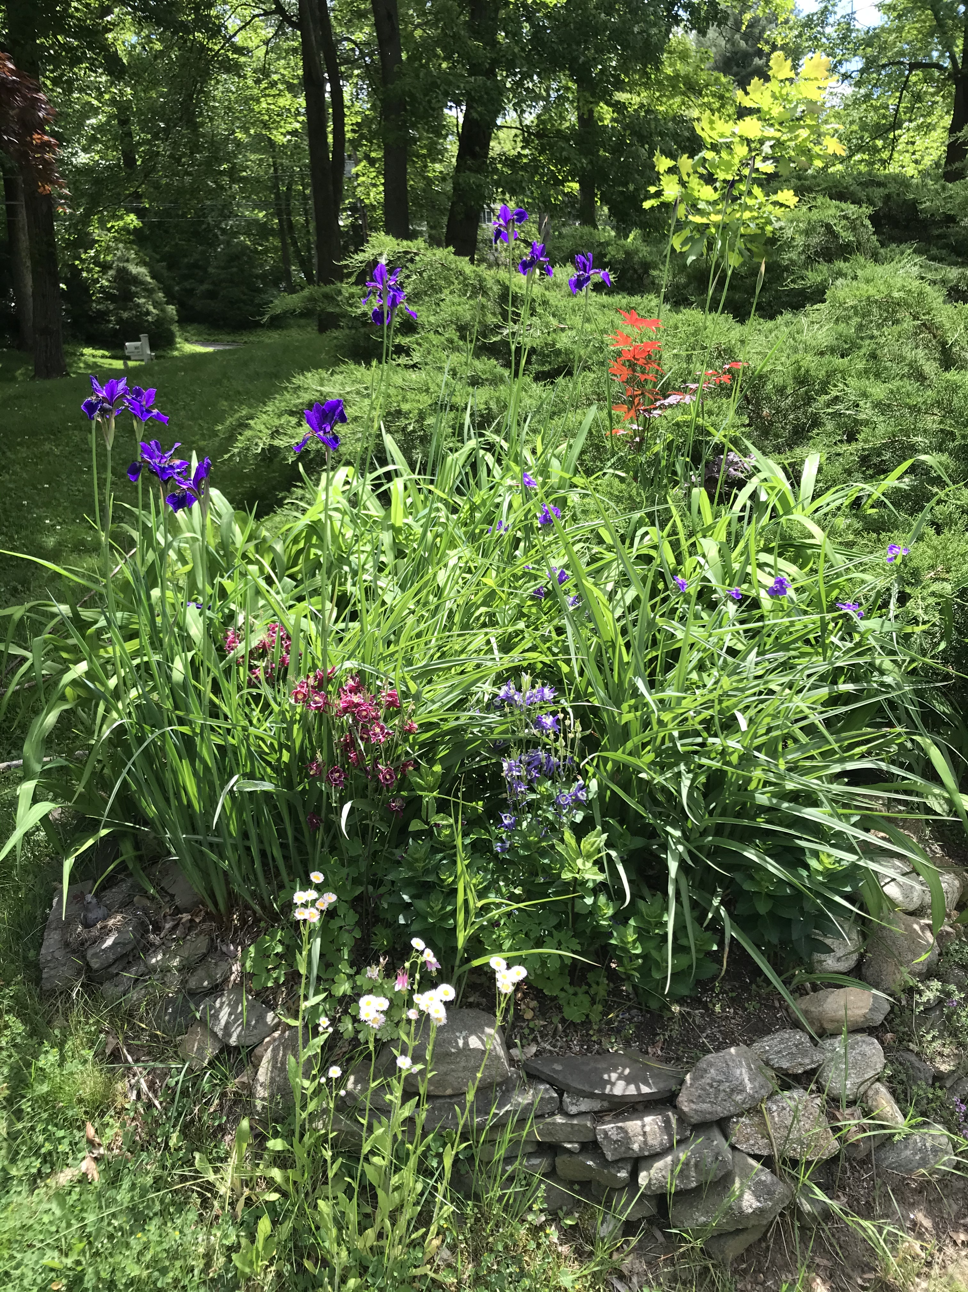

photo by Mary Hogue

2030 Goals*
- Install pollinator gardens at 100% of schools to be used as on-site field trips/ laboratories
- Promote Pollinator Pathway & Green Corridor programs so that residents and businesses understand the importance of their participation. Encourage participants to certify their landscape and prominently display signage to promote the programs
- Increase awareness and control of invasive species
- Expand organic landscaping practices to all Town golf courses
- Expand use of residential electric-powered options for landscaping tools
- Encourage local landscape companies to use electric blowers, chainsaws and other landscape tools
- Adopt ordinances banning and/or regulating turf fields, glyphosate, chlorpyrifos and other cancer-causing pesticides
- Adopt a version of the state drought ordinance to mitigate against excessive watering
*Some goals are ambitious, and may need more time to achieve target participation rates; others can be achieved sooner, but work on all goals should begin as soon as possible

How Do We Reach Our Goals?
- Educate residents through seminars and online resources on the use of organic landscaping; pollinator-friendly options; low-impact development to manage stormwater runoff; and conversion of portions of lawn to wildflower meadows
- Educational outreach to local nurseries to promote sustainable, non-invasive plantings
- Provide resources that outline invasive species identification, removal techniques, and replacement options
- Promote the benefits of non-polluting, quieter landscaping equipment to local landscaping companies
- Judicious use of organic tick, mosquito and flea control, to prevent killing bees and other beneficial insects

FOR MORE INFORMATION

NOFA Standards for Organic Land Care
DEEP Organic Lawn Care
Low Impact Development
DEEP Sustainable Practices and Resources for the Landscaping and Lawn Care Industry

Connecticut Invasive Plant Working Group

Enhancing your Backyard Habitat for Wildlife

